*Entertainment Data Analysis*

*Wireframe Documentation*

# Home page

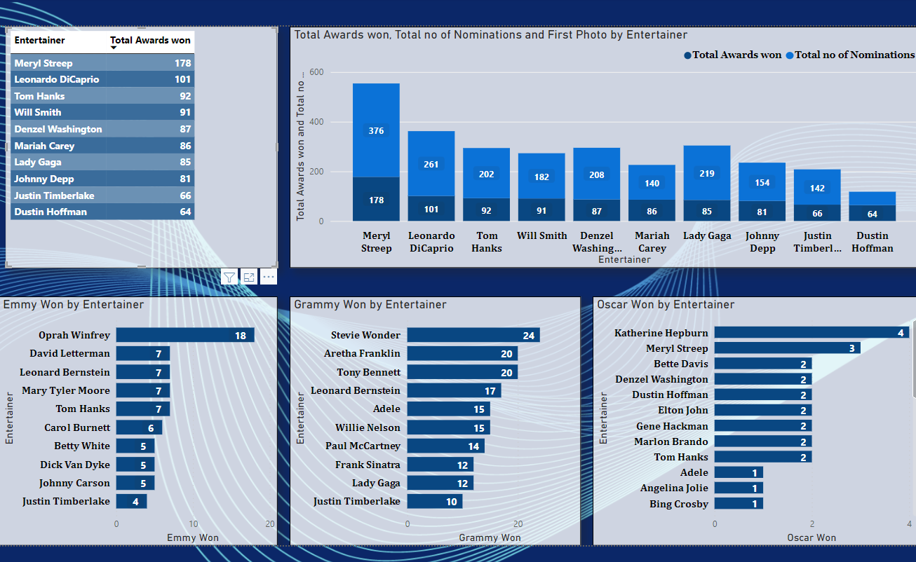

**(Figure 1)**

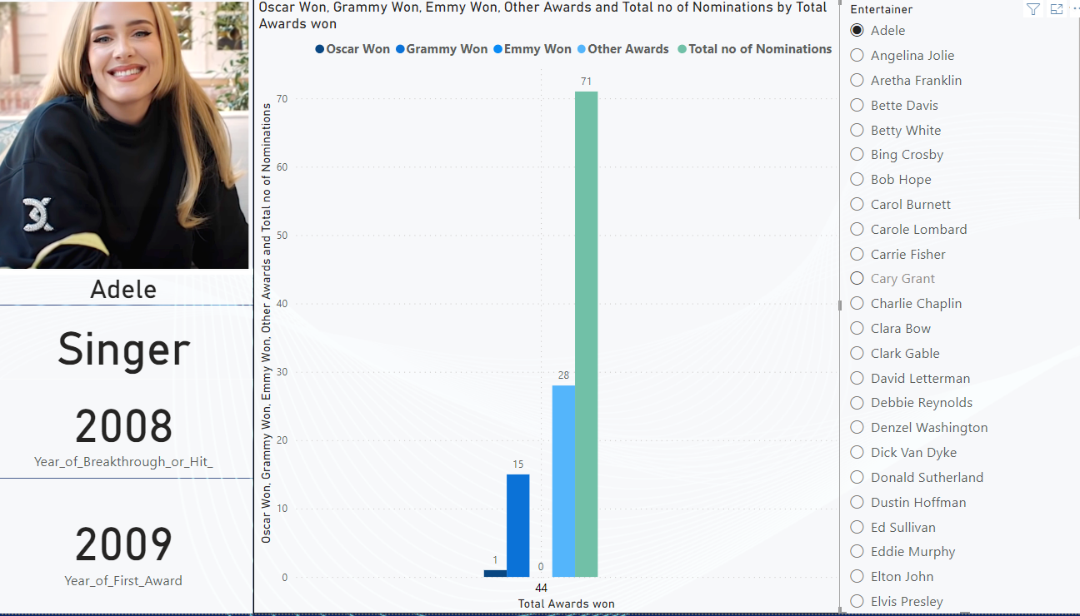

**(Figure 2)**

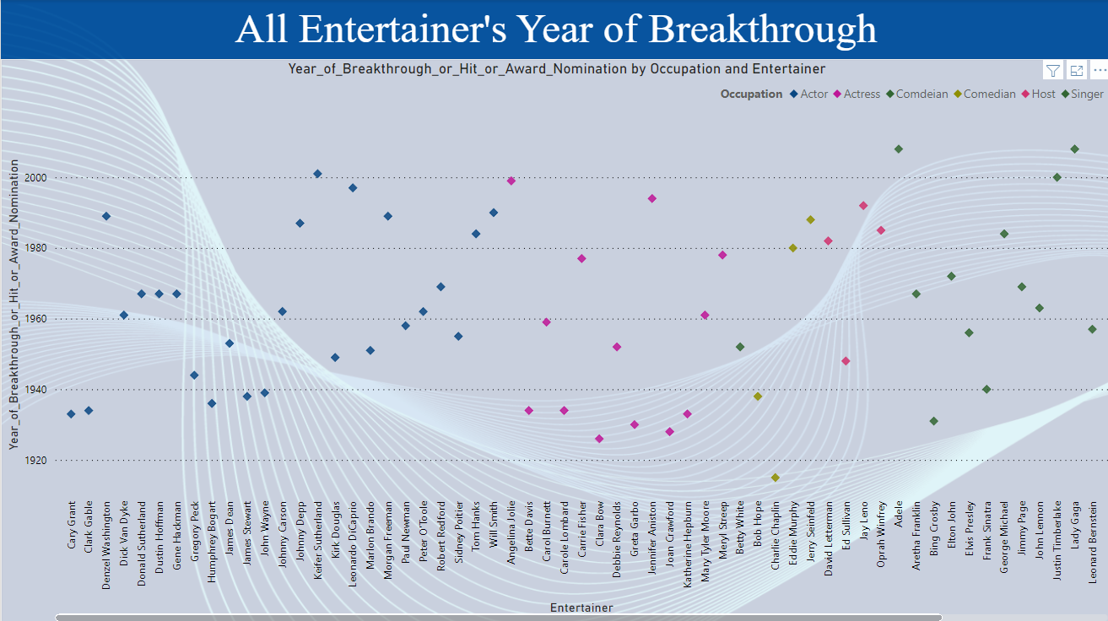

**(Figure 3)**

## Analysis of Top 10 Entertainers:

## 

## Meryl Streep and Leonard DiCaprio, who received the majority of nominations and awards, are clearly the top performers in the above graph, but if we look closely, Mariah Carey and Johnny Depp have the highest success rates at 61.4% and 52.6%, respectively.

## Analysis of Individual Award Category:

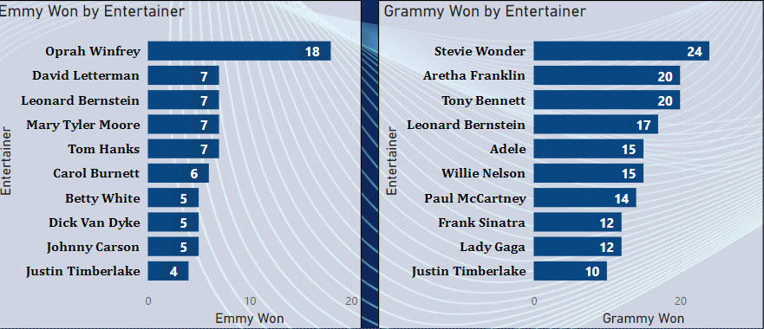

It should be noted that Stevie Wonder, one of the best singers and songwriters, won the majority of Grammy awards in the singing category while Oprah Winfrey won the majority of Emmy awards over the years for various television programs.

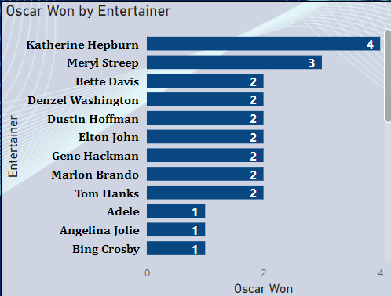

It is evident from the graph above that Katherine Hepburn has won the majority of Oscars over the years for films like On Golden Pond, Guess Who's Coming to Dinner, and The Lion in winter.

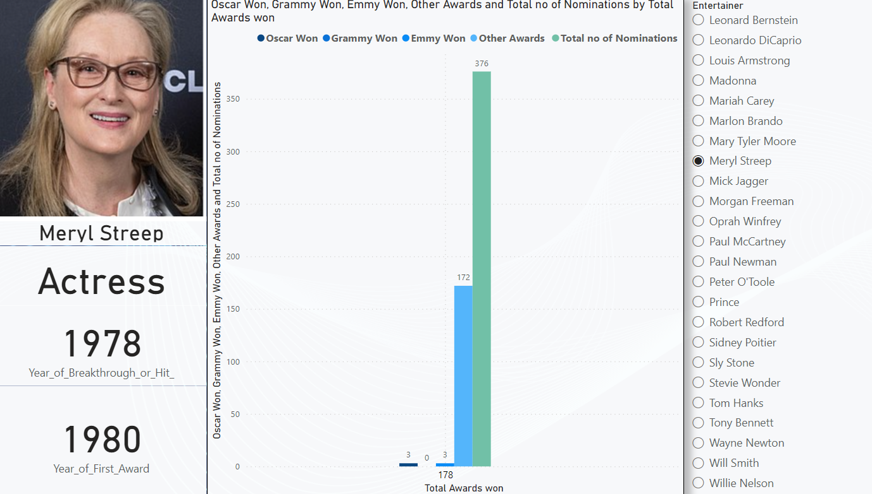

Each performer is represented by their picture and career highlights on the dashboard above. To access the information for each entertainer's specific details, the user must first choose their name.



According to the aforementioned graph, the majority of breakthroughs for performers occurred between the 1940s and 1960s.